Whiteklay Technologies Pvt Ltd

Admin panel Assignment

Frontend-React js.

Step1 –download project on gitHub.

Step2- open admin_frontend folder project on visual studio.

Step 3– install npm library by using this command (npm install ).

Step 5-start the project by using this command (npm start).

Database Mysql

Step1 -Create database :-

CREATE DATABASE `admin_application`

Step2- Create table :-

CREATE TABLE `employee` ( `id` int NOT NULL AUTO_INCREMENT, `name` varchar(45) DEFAULT NULL, `email` varchar(45) DEFAULT NULL, `role` varchar(100) DEFAULT NULL, `organization` varchar(100) DEFAULT NULL, PRIMARY KEY (`id`)) ENGINE=InnoDB AUTO_INCREMENT=28 DEFAULT CHARSET=utf8mb4 COLLATE=utf8mb4_0900_ai_ci

Step 3 - Create table:-

CREATE TABLE `organizational` ( `id` int NOT NULL AUTO_INCREMENT, `org_name` varchar(150) DEFAULT NULL, `size_of_organization_unit` int DEFAULT NULL, `description` varchar(2000) DEFAULT NULL, PRIMARY KEY (`id`)) ENGINE=InnoDB AUTO_INCREMENT=12 DEFAULT CHARSET=utf8mb4 COLLATE=utf8mb4_0900_ai_ci

Step 4- Create table:-

CREATE TABLE `roles` ( `id` int NOT NULL AUTO_INCREMENT, `name` varchar(100) DEFAULT NULL,

`description` varchar(2000) DEFAULT NULL, PRIMARY KEY (`id`)) ENGINE=InnoDB

AUTO_INCREMENT=18 DEFAULT CHARSET=utf8mb4 COLLATE=utf8mb4_0900_ai_ci

Backend-Nodes, Express Js

Step 1- open admin_backend folder project on visual studio.

Step 2- install npm library by using this command (npm install ).

Step 3- start the project by using this command (npm start).

**Successfully installed project**

Then see the Admin page look like this

Step 1-: Enter username and password

Username –admin

Password-admin

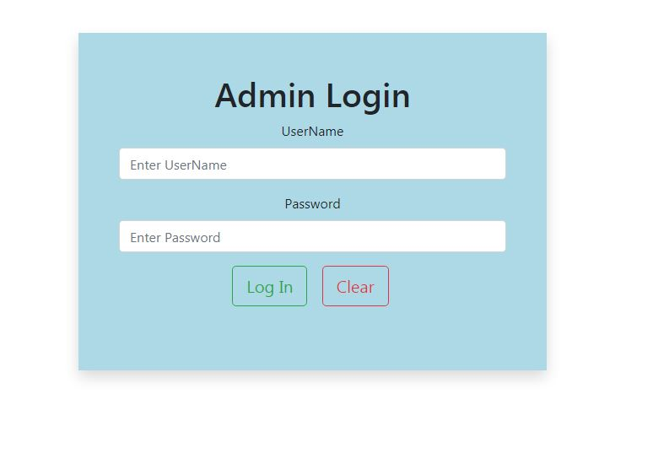

Step 2- after login success then see the following page

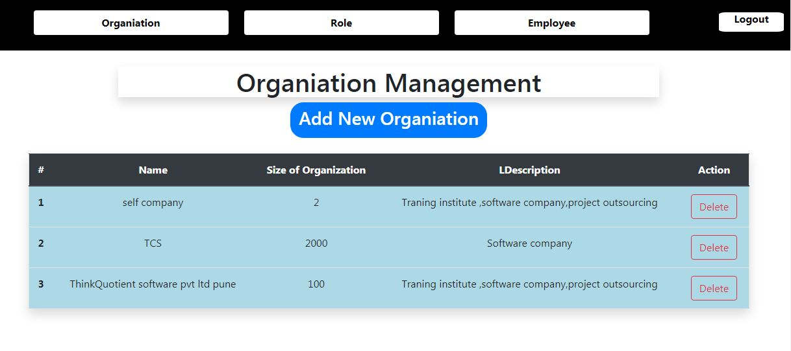

Step 3-

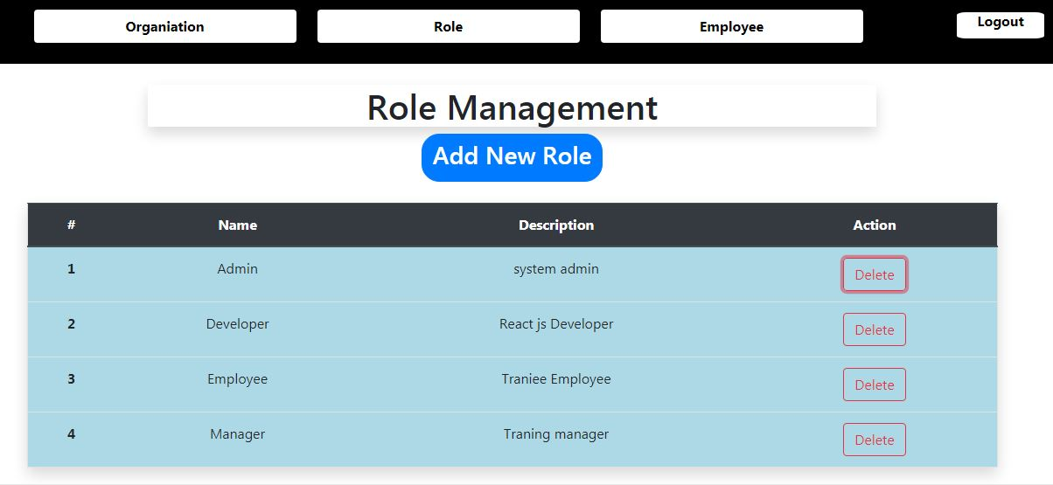

Step4-: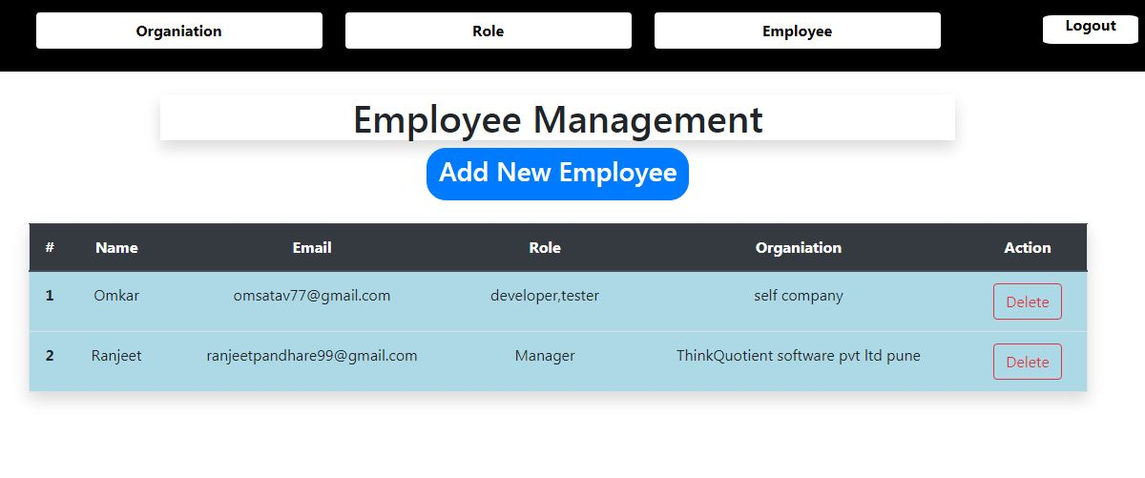Step 5:-